**Guidelines for Apex Oracle Application Express**

1. Extract the all the files in (WindowsC:) from Zipped Folder named OCI.
2. Then, Open folder named 11g and extract it, which is Oracle Database 11g Edition. And there is setup icon and, run it as Administrator and install it.

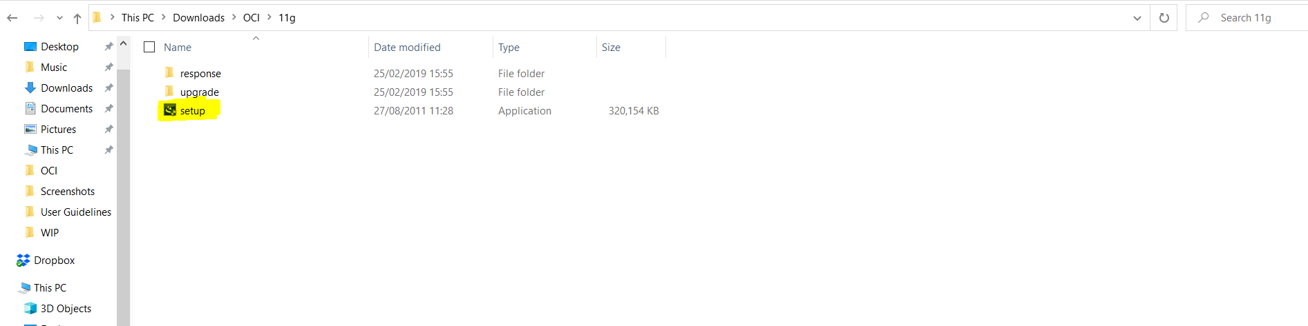

1. We have to set up Password for Oracle Database during installation and after sometime it will take some times for installing.
2. After installed, we need to upgrade 11g edition into 19. For that,
3. We need to extract sub-folder (apex_19.2 or apex_19.2_en) in Windows(C) location first and it will appear as apex.

Similarly, we also need to extract instantclient_19_11 for OCI.

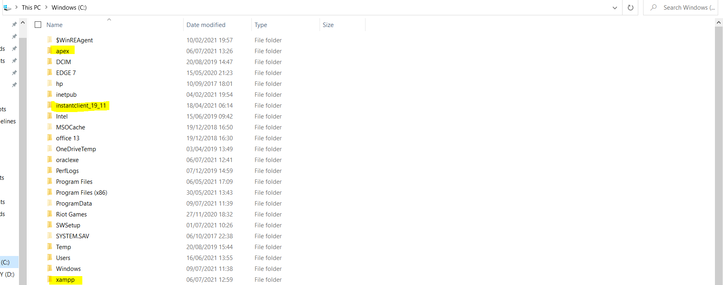

1. Then, open Command Prompt (cmd) and Follow these steps for upgrading 11g into 19 edition.

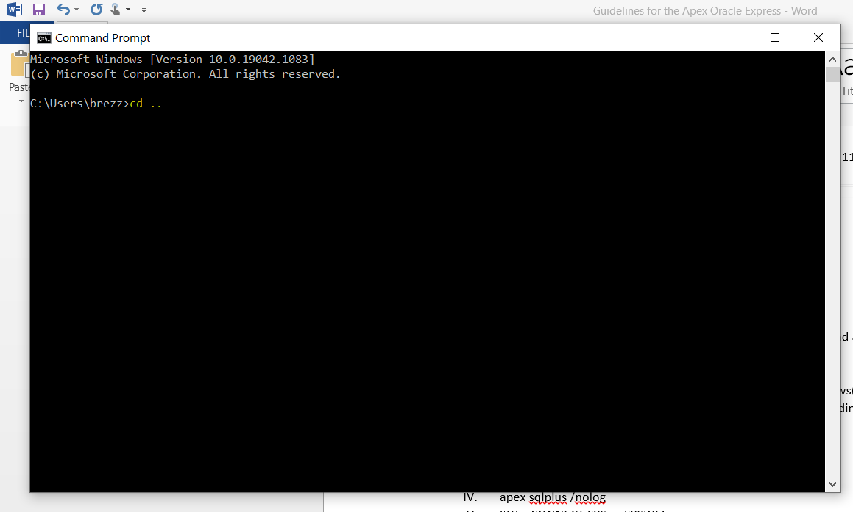

1. Type cd ..
2. cd ..
3. cd apex
4. apex sqlplus /nolog
5. SQL> CONNECT SYS as SYSDBA

Enter Password

1. @apexins SYSAUX SYSAUX TEMP /i/

It will took about 7 to 15 minutes

After completing/ Disconnected message will appear

you will be switch for c:\>apex

1. sqlplus /nolog

CONNECT SYS as SYSDBA

Enter Password again.

1. Copy and paste it @apex_epg_config.sql C:\

Final Message will be Commit Complete. It will take sometimes.

7. If you need to create the admin account

@apxchpwd

Set admin user_name

Set email

Set password

How to create new workspace

8. localhost:8080/apex/apex_admin

in Username, enter ADMIN

in Password, Enter the Password entered in Step6

===================

Install Oracle Apex 11g

Upgrade Apex to 19.2

Making Workspace in Oracle APex